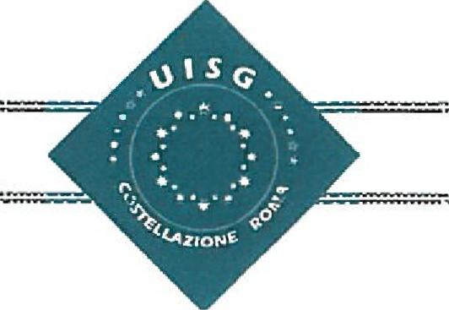**ROME CONSTELLATION’S ASSEMBLY**

**Rome, January 9th and 10th 2020, at Monte Cucco**

Dear sisters in Jesus, the Lord who calls us to be a mission.

In communion with the Church, that is living intensely the extraordinary Missionary Month and the Synod of Amazonia, we send our greetings of joy and peace to you and your Institutes.

The Constellation Committee of Rome, the most international of all constellations, notifies the celebration of its **annual Assembly**, inviting all the General Superiors of the Constellation to participate in this meeting, which is always an opportunity to learn, share and strengthen our identity as women consecrated in the Church, welcoming the challenges that arise in our Institutes today.

We will send you the draft of the program, with the different activities to be realized; final program will be sent soon.

|  |  |
| --- | --- |
| ***Date*** | January 9th and 10th |
| ***Topic*** | ***Sowers of prophetic hope... generating dynamisms of INTERCULTURALITY"*** |
| ***Program*** | **Day 9**  Interculturality in consecrated life, ***Fr. Tim Norton***  **Day 10**  Interculturality testimonies  Encounter/dialogue with Mons. José R. Carballo. Secretary of CIVCSVA  UISG Information  Elections of the new Constellation’s Animator Team - Rome |
| ***Venue*** | Casa di Esercizi Spirituali Nostra Signora, Madre della Misericordia, Via di Monte Cucco, 25 - 00148 Roma |
| ***Registration*** | 200€ (complete accommodation and expenses of organization – payment must be paid during registration on-line  For the partial participation, payment will be during the assembly. |

As in previous years, the registration, can be done online:

<http://bit.ly/RomeConstellation2020>

Confident that, this opportunity for meeting and reflection will allow us to find paths of interculturality being sowers of prophetic hope, we invite you to reserve this dates in your agenda and proceed, as soon as possible, to do the registration. Thank you

We greet you with fraternal love.

*Anabela, Luigina, Ivete, Beatrice*

Rome, 4th November 2019