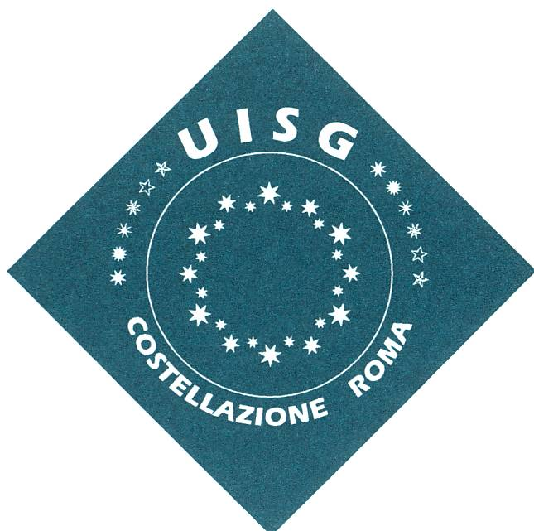
Rome Constellation Assembly
9 - 10 January 2020

“Sowers of prophetic hope…”
generating dynamisms of INTERCULTURALITY

PROGRAMM

9 January 2020

8.30h - 9.00h  9.15h  9.30h  10.30h  11.00h  12.15  13.00h | Arrivals – Registration and distribution of material  Opening prayer and Word of welcoming  Input: “Challenges and opportunities of interculturality in our religious communities and for our Leadership”. (P. Tim Norton SVD)  I Session - Interculturality: Concepts and Definitions  Coffee break  II Session: The intercultural journey of Jesus and of the early Church  Eucharistic Celebration: in English - P. Tim Norton  Lunch
15.00h  15.10h  16.30h  17.00h  18.15h  18.45h  19.30h | A moment of prayer with Mary  III Session - Christian Leadership in intercultural communities  Coffee break  IV Session – Intercultural Religious Life/ Consecrated Discipleship  Short input by Don Andrea Palamides  Time for personal Integration  Supper
10 January 2020

8.30h  8.45h  10.15h  11.45h  11.00h  12.00h  13.00h | Opening prayer  Roundtable discussion: experiences…  - Presentation  - Internationalization of an Institute and the care of Interculturality, Suore Ospedaliere della Misericordia  - Dynamisms of interculturality within a General Council, Missionarie Serve dello Spirito Santo  - Initial formation and challenges from internationality, Suore di Santa Giovanna Antida Thouret  Coffee Break  Preparing for the meeting with Mons. José Rodriguez Carballo  Meeting with Mons. José Rodriguez Carballo  Eucharistic Celebration: Mons. José Rodriguez Carballo  Lunch
14.30h  15.30h  16.30h | A word from the UISG President and Secretary  Renewal of the Rome Constellation Committee - UISG  Conclusion and final Prayer

(Simultaneous translation will be available in Spanish, Italian, English)

