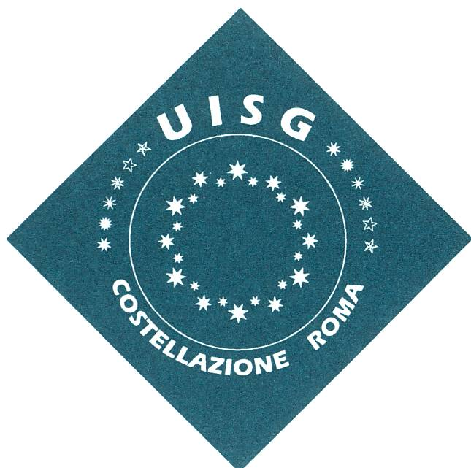
Rome’s Constellation Assembly
10 January 2019

“The Prophecy of Holiness in Religious Life today”

PROGRAM

8.30h  9.00h  9.15h  10.15h  10.45h  11.45h  13.00h  14.30h  15.30h  15.50h  17.00h | Arrival - registration and material’s handing in  Opening Prayer  Conference: Fr Amedeo Cencini – part 1  Break – Coffe  Conference – Part 2  Resonance in the groups and assembly dialogue  Lunch  Resume of the work: Consultation to present possible delegates  Break - Coffee  UISG’s information  Conclusion: Prayer

